**CREATE A DIFFERENTIAL DRIVE ROBOT IN WEBOTS SOFTWARE**

PROCEDURE TO CREATE A BOT:

* Install a webots software in windows, mac, ubuntu.
* Open the software click wizard, click new project and name the project as diff_drive, click ok and finally add rectangular arena.
* Open the rectangular arena(left side called as scence tree) and click “+” in the screen, click base node, select robot and click add button.
* Select robot in scence tree click children and select”+” in the screen click base node and go to transform and click add button.
* Select shape node and go to geometry and double click select cylinder and select add.

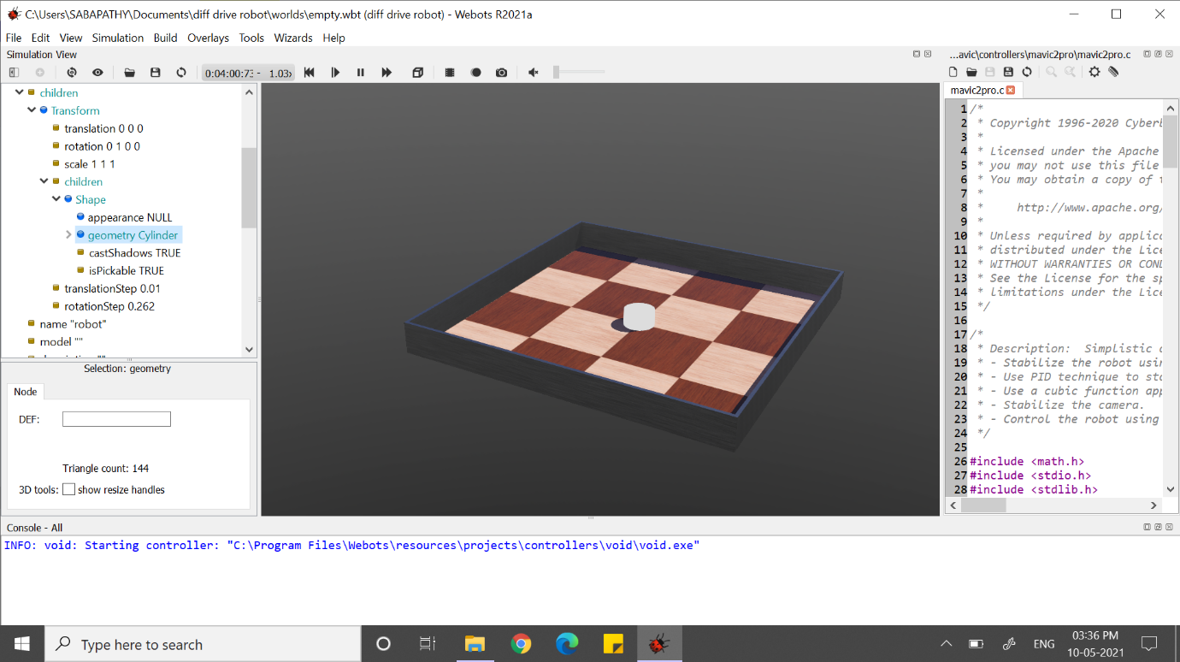

Fig 1.1(cylinder is opened in the rectangular arena)

* Under geometry cylinder select (height = 0.08m, radius= 0.045)
* Then in shape node select appearance null and click base node and select PRB Appearance and click add.
* Under appearance PBR Appearance click base colour(red=0,green=0,blue=1) and then increases the roughness=1 and metalness =0

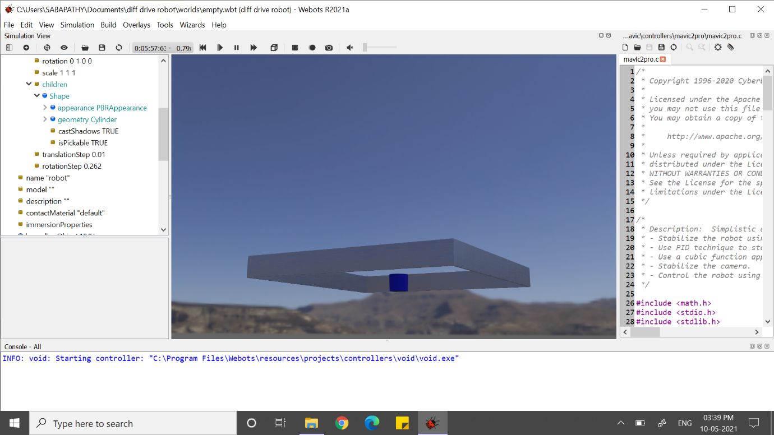

Fig 1.2(half cylinder is appeared below rectangular arena)

HOW TO RAISE THE CYLINDER ?

* Select the transform node and click translation(y=0.0415) save the environment.

HOW TO REUSE THE OBJECT:

* Click transform node and name it as (DEF=”body”)
* Then select bounding object and double click select use body(transform) and select add button.
* The fig 1.3 is shown in the environment.
* Then select physics node and click base node select physics and click add.
* You can able to see the bounded objects.

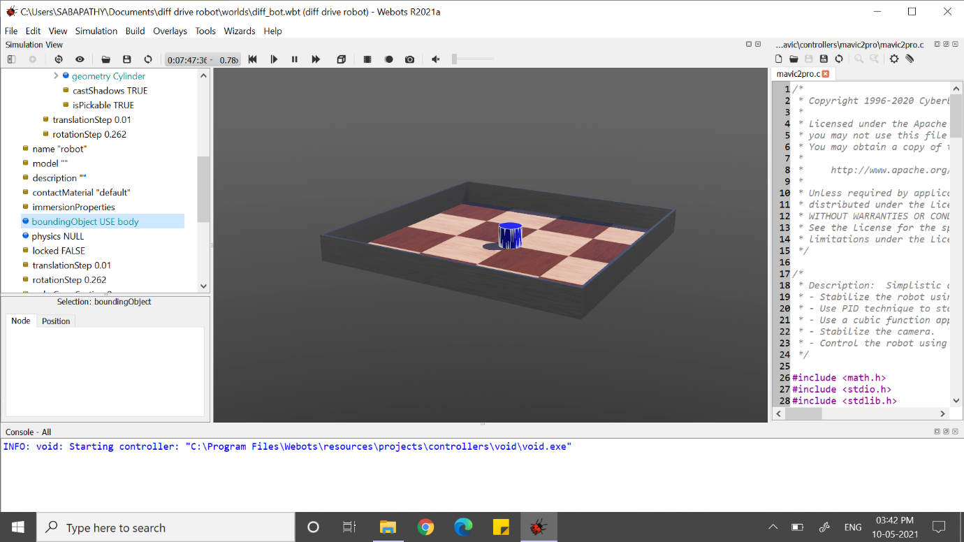

Fig 1.3(reusing the object)

ADDING OF WHEELS TO THE BOT:

WHEEL

MOTOR

HINGE JOINT

BODY

* Click DOF body transform and + and add new node then click base node and select hinge joint and select add.
* Under hinge joint in(DOF body transform) select joint parameter and double click select base node and click hinge joint parameter and click add.

ALONG WITH HINGE ADD MOTOR:

* Click hinge joint select devices and base node click rotational motor and then add
* Under “rotational motor” click name and give as “motor 1” and enter.
* Go to end point null give double click and click base node and select solid and add into it.
* Open end point solid and go to children and select + and click base node and select shape and select add.
* In end point (solid) node select children and select shape and click geometry null double click and select base node and add cylinder and add.

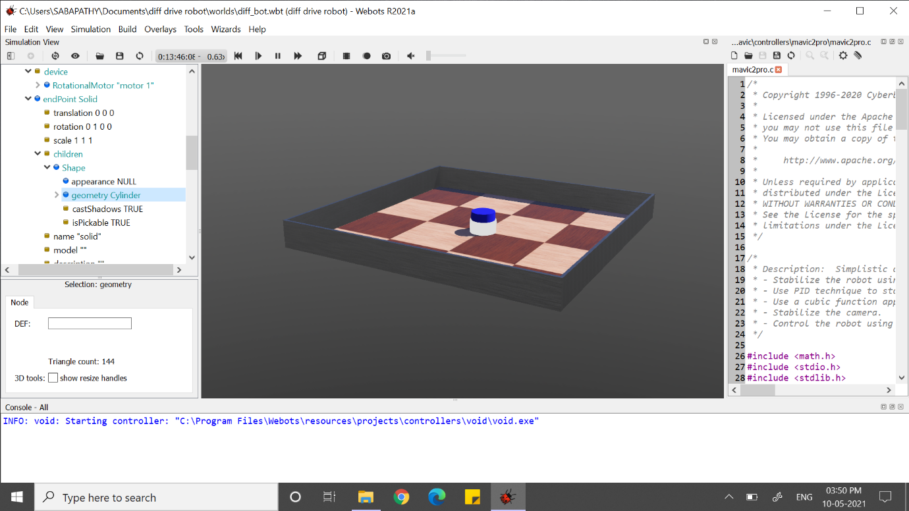

fig 1.4( other object is created)

* Under geometry cylinder (height=0.01,radius=0.025)
* Wheel is hidden inside the body.

WAY TO CHECK THE WHEEL OR HOW TO RAISE THE WHEEL?

* In end point solid select (translation= 0.045,0.025,0) & (rotation= 0,0,1,1.57[angle])

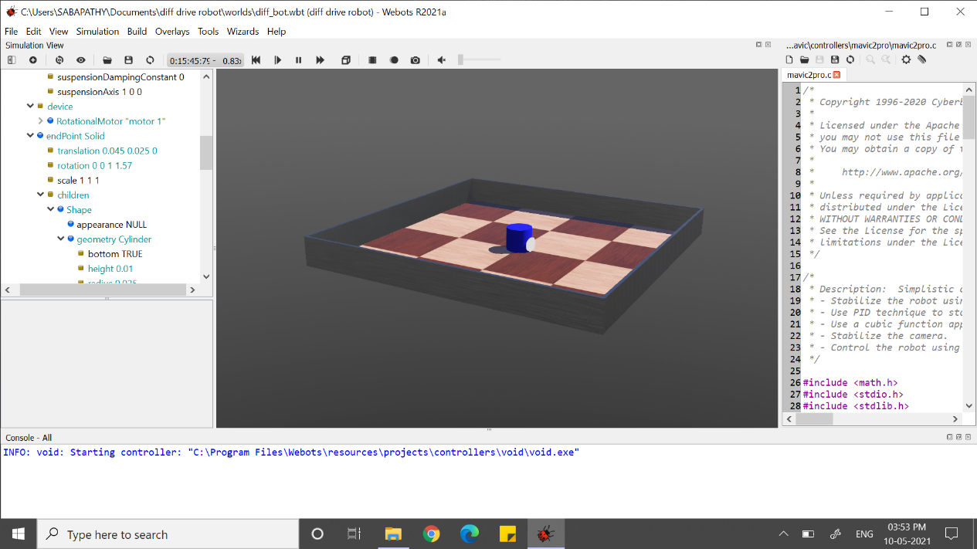

Fig 1.5( wheel is appeared in robot)

CHANGE OF ANCHOR POSISTION:

Fig(1.6) add x and y axis in anchor

* Select end point node then go to children and select shape and select appearance and double click and click base node and select PBR appearance and the add.
* Click shape node and select appearance PBR appearance and select (base colour [red=1], roughness=1, metalness=0)
* Children node select shape and name it as “wheel”
* In bounding object select + and select use and click wheel and add it.
* Select physics click base node and select physics and add it.
* Click physics node and name it as “wheel_physics”

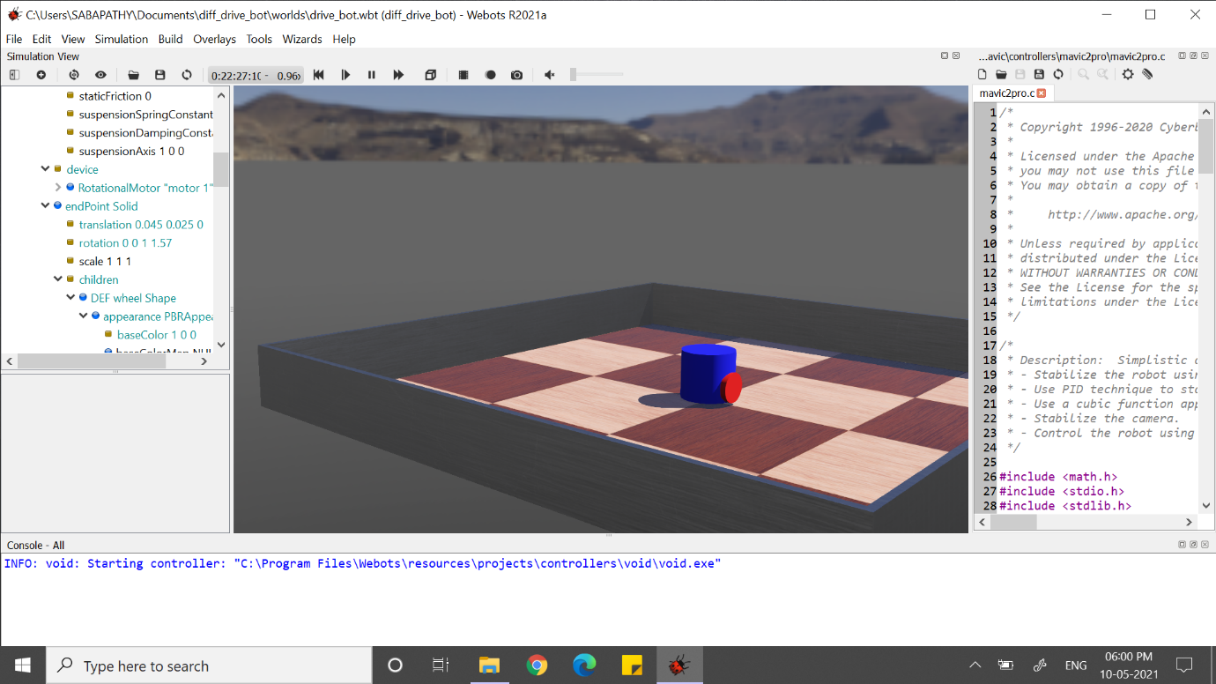

Fig 1.7 (wheel 1 of a bot)

* Similarly do it for wheel 2 of a bot.

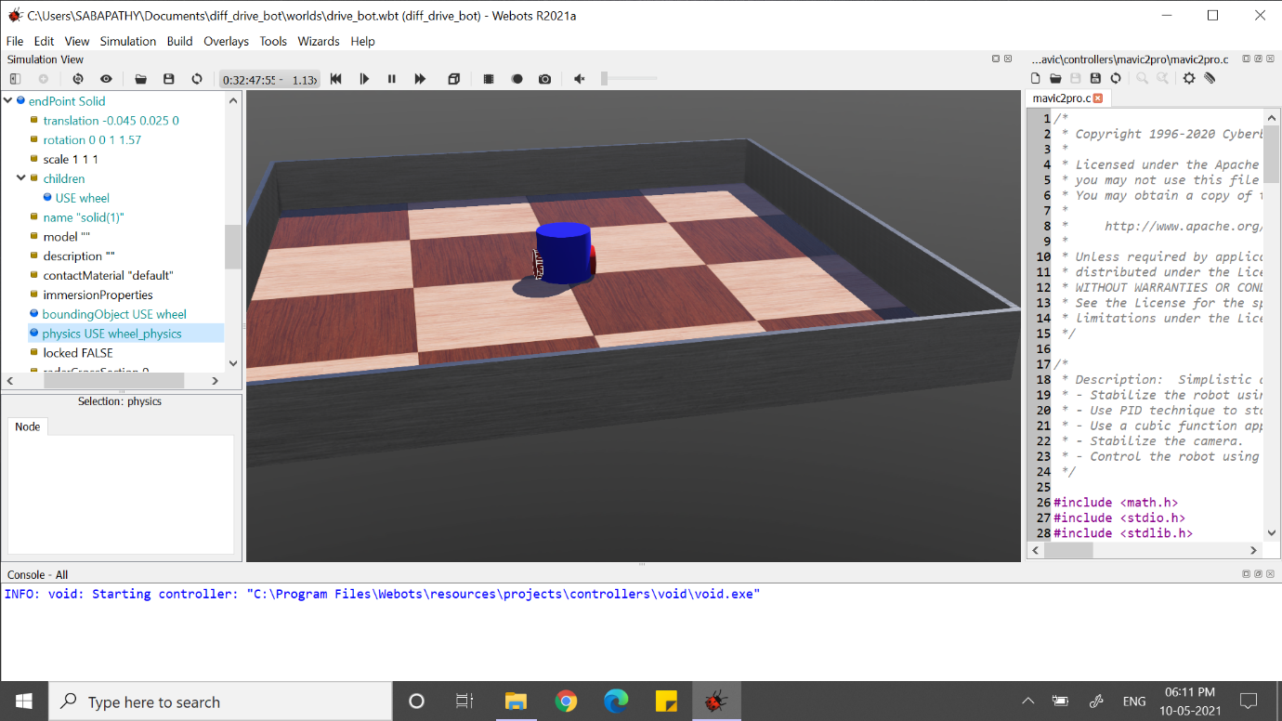

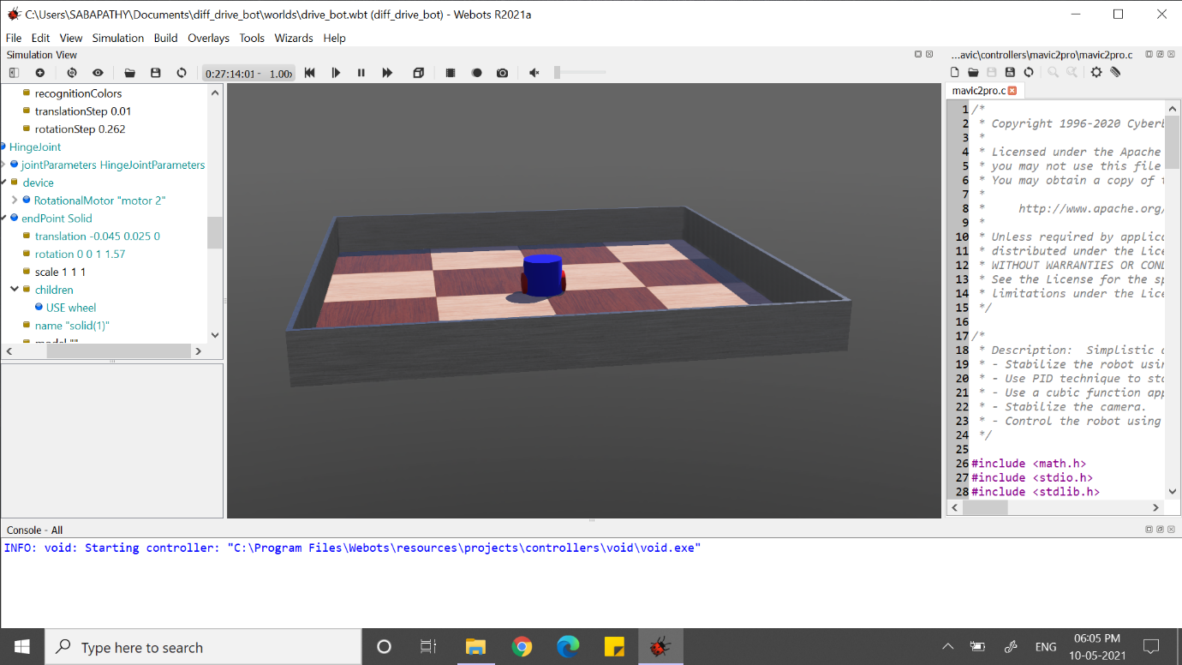

Fig 1.8( wheel 2 of the robot)

MAKE AN EYE FOR THE ROBOT:

* Select the robot node and click rotation(0,1,0,0.54)
* Under solid node select children and click “+” click base node and select shape and click add
* Under shape node select geometry null and give a double click and click base node and click box and press add button.

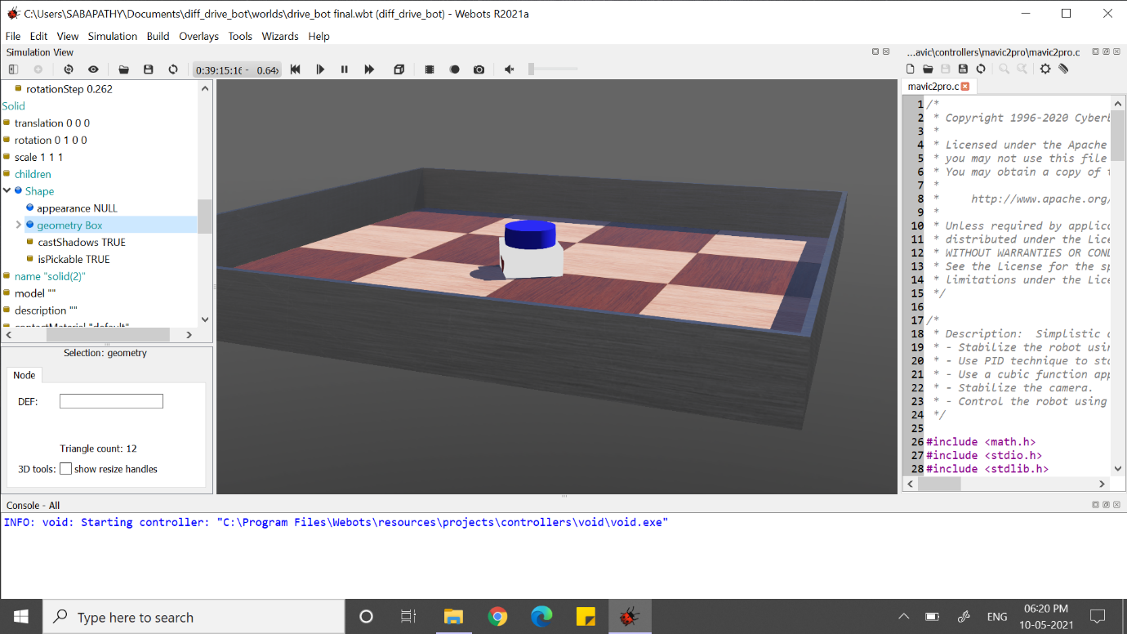

Fig 1.9(other object is created)

* Under geometry box node give a size as(0.005,0.005,0.005)
* Select appearance and click base node select PBR appearance and add it
* Select PBR appearance give (base colour red=1, roughness=1, metalness=0)
* Save the environment.
* Eye is hidden in the environment
* In solid node select translation as(0.015,0.07,0.045)
* Then select shape node and double click and save as DEF=”eyes”
* Similarly, follow the same steps and you will get the two eyes in the robot.

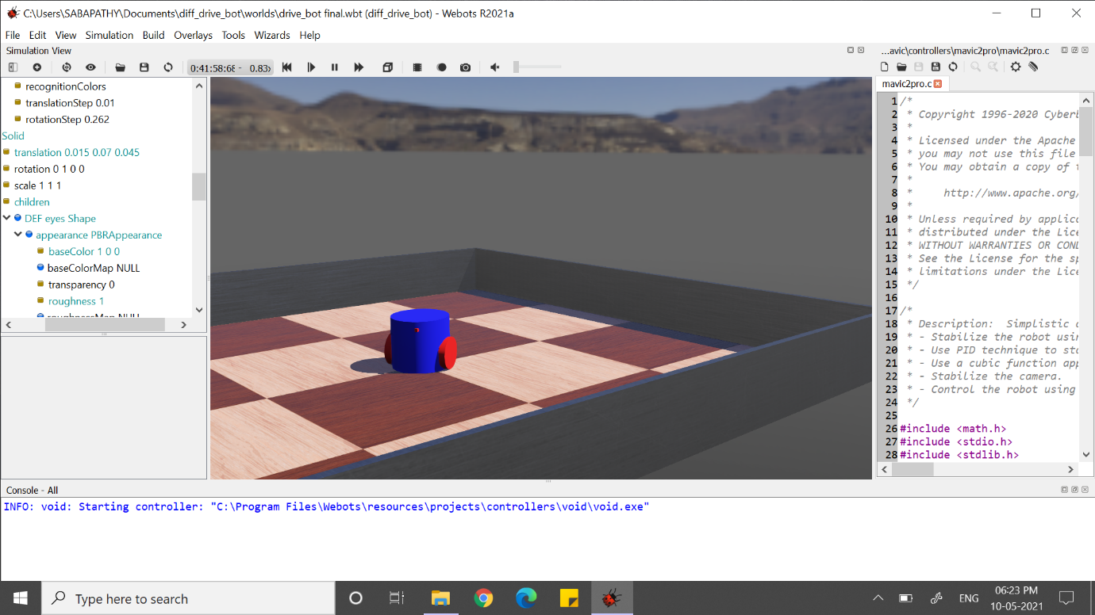

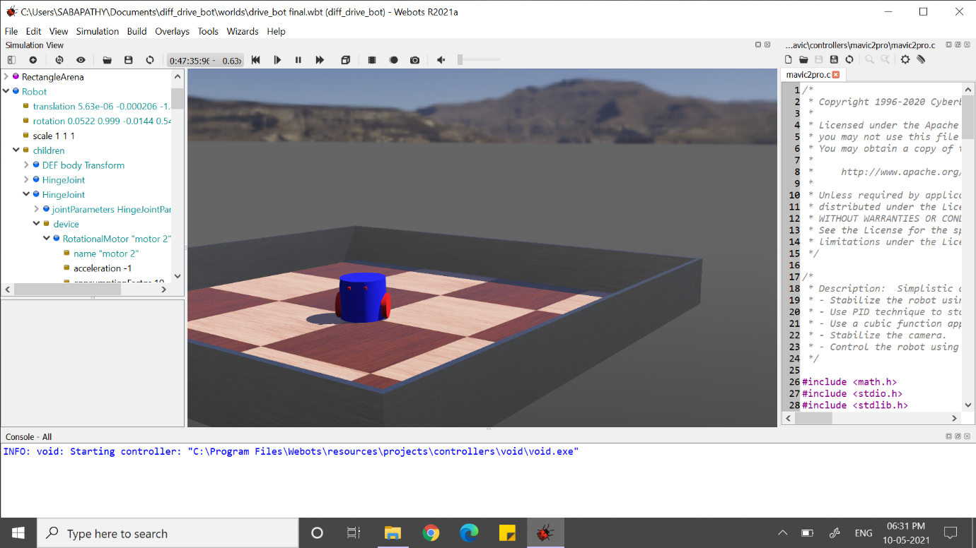

Fig 1.10 a,(one eye in a bot) b,(two eye in a bot)

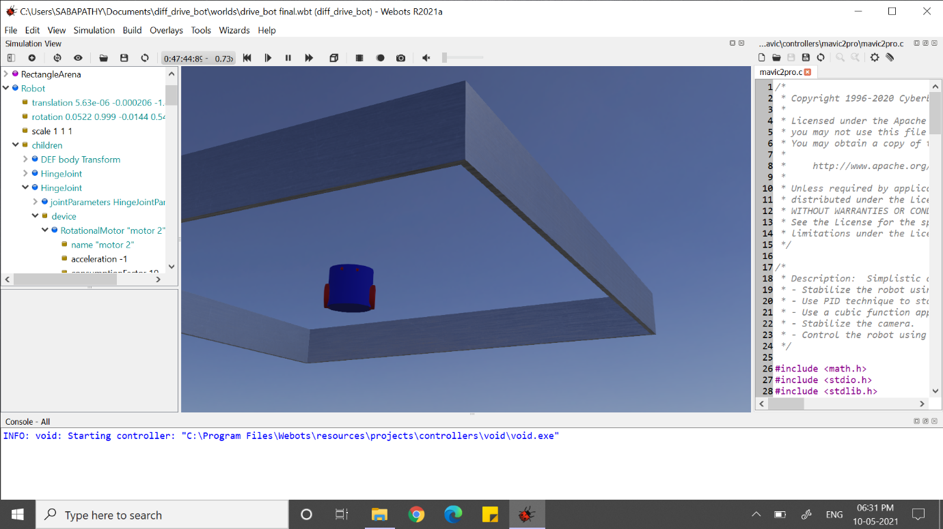



Fig 1.11( implemented a differential drive in webot environment with two wheels and eye)